[1]

D.S.P. Lab 2- Sensor Noise and Quantization Noise Measurements

Aliana Tejeda, Wesley Madden, *Member, CPET*

***Abstract*—Every signal has a certain level of noise associated with it. Noise can be good or bad depending on what is being assessed. When it comes to the LM61 temperature sensor, we get to learn how much noise is too much, and how much noise just isn’t enough. Furthermore, noise can be distributed uniformly to improve a signal, and this uniformity can be used to improve the ADC of a signal.**

***Index Terms*— Microprocessors, Statistical Learning,**

# INTRODUCTION

T

HE purpose of this lab was to further investigate the process of dithering and its effect on signals. The LM61 temperature sensor had a very rough step like response to being touched and let to cool down. This step like response is due to the lack of noise. This lack of noise prevents the ADC from making accurate conversions of the real signal. This lab investigated the workings behind uniformly distributed random data, data analysis, reducing quantization error, and improving the overall precision and or accuracy of the system.

# LM61 Temperature Sensor Response

## Analysis of Arduino’s random signal generation\

Our first step to understanding dithering is to first observe how Arduino can create random variables via the function rand(). We gathered this data from Arduino then analysed it by plotting the samples and creating a histogram. 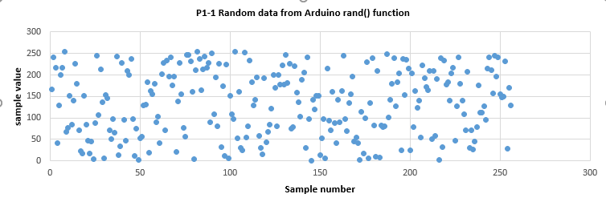

Figure 1. plot of random data given by Arduino’s rand() function.

Looking at the histogram and plot, we can see that the rand() function is able to create an evenly distributed amount of variables because we see that the cumulative percentage of data in the histogram is almost a straight line.

## 

Figure2. histogram of random data given from Arduino’s rand() function

## Assessing sensor noise, accuracy, and SNR

Next, we measured the temperature sensor signal in order to analyze the signal to noise ratio of both the temperature sensor and the ADC combined. We measured just the straight reading from the temperature sensor with no changes to ambient temperature to see how the system looks at a steady state. We plugged these readings into excel to create a plot, histogram, and other statistical data.

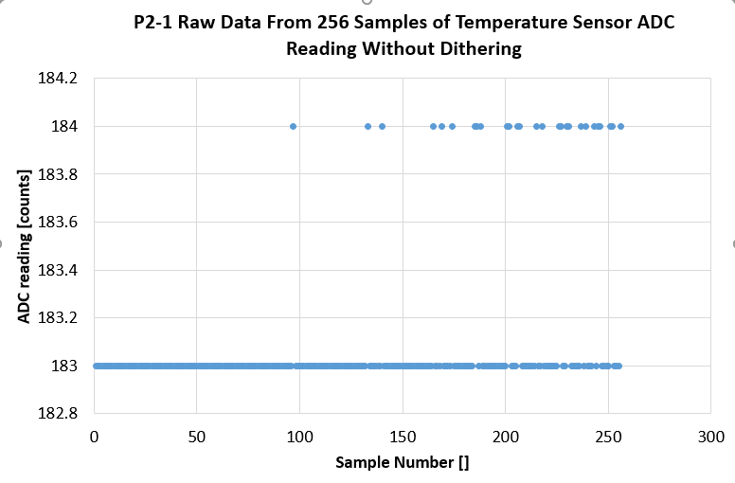

Figure 3. plot of LM61 raw data sensor ADC readings. 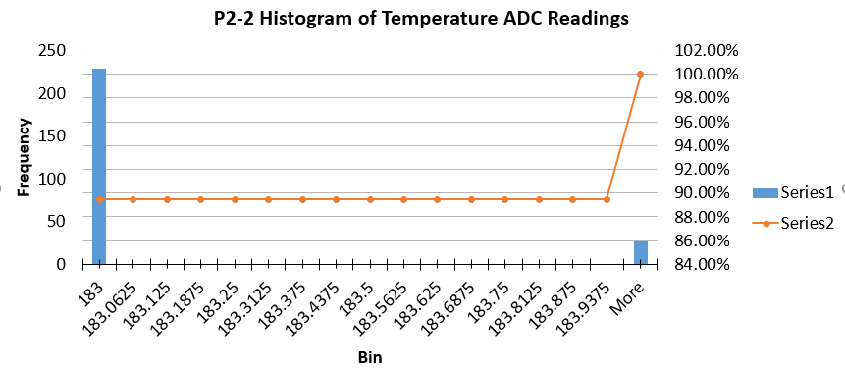

Figure 4. Histogram of raw temperature ADC Readings.

|  |  |  |
| --- | --- | --- |
| **Table 2-1 Calculations based on raw temperature sensor ADC readings** | |  |
|  | Value | formula |
| mean | 183.1054688 | AVERAGE(A1:A256) |
| stdev | 0.307758141 | STDEVA(A1:A256) |
| SNR (dB) raw | 55.4898353 | 20*LOG10(C2/C3) |
| Quantization Noise (in LSB) | 0.29 | 0.29 |
| SNR (dB) Qn only | 56.00606635 | 20*LOG(C2/C5) |
| Typical Error (in LSB) | 0.019234884 | C3/SQRT(256) |

Figure 5. statistical data of the sample set of raw ADC readings

From the plot and histogram, we can see that there are a decent amount of erroneous readings. These outliers are problematic, as the histogram shows us that 12% of our samples are inaccurate. We can also see that the SNR is a bit lower in our raw readings compared to just the quantization noise. This means that very little source noise was added to the signal.

## Adding dithering noise

Because the samples we took from the raw ADC were not randomly distributed, we cannot directly average the samples to reduce quantization noise. However, we will add in dithering noise to the circuit before we perform the ADC in order to average the samples. This will solely be done to increase precision. We are going to add a circuit specifically to increase noise by dithering, then analyze the samples in excel. We are going to send a straight signal into the circuit we build and see how much noise is added into the ADC.



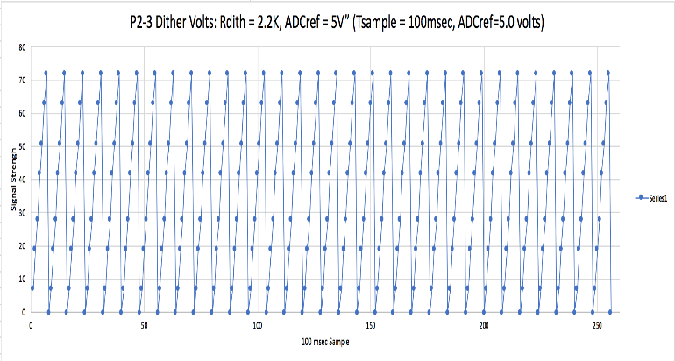

Figure 6. graph of dithering voltage over 100 msec samples.

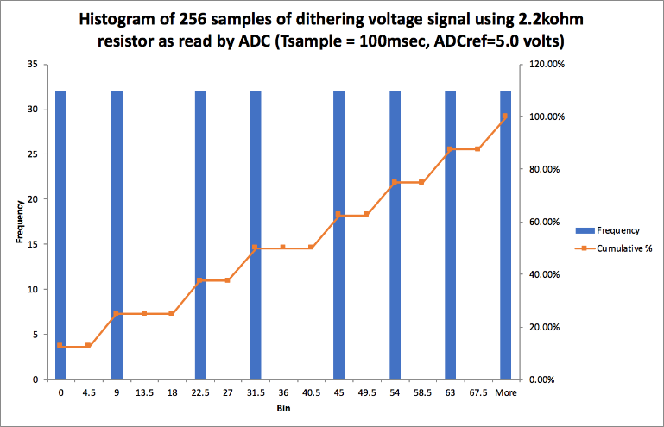

Figure 7. histogram of dithered voltage.

|  |  |  |  |  |
| --- | --- | --- | --- | --- |
| Table 2-2 Calculations based on temperature sensor ADC readings using dithering and 256 points averaged per sample | | | | |
|  | value 1x sampling | value 16x sampling | value 160x sampling | value 256x sampling |
| mean (ADC CV) | 187.4609375 | 188.8936078 | 188.865 | 188.8331641 |
| stdev raw (ADC CV) | 1.451989001 | 0.322160995 | 0.049221389 | 0.033603052 |
| SNR (dB)raw | 42.21894916 | 55.36288607 | 71.67995242 | 74.9939908 |

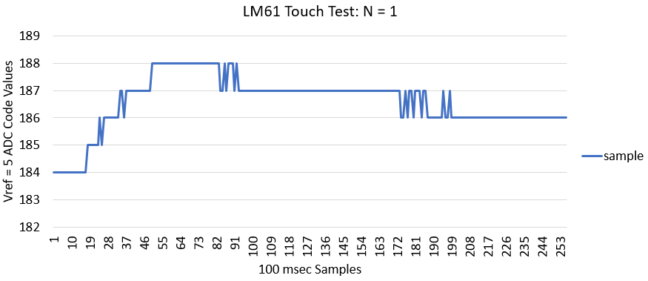

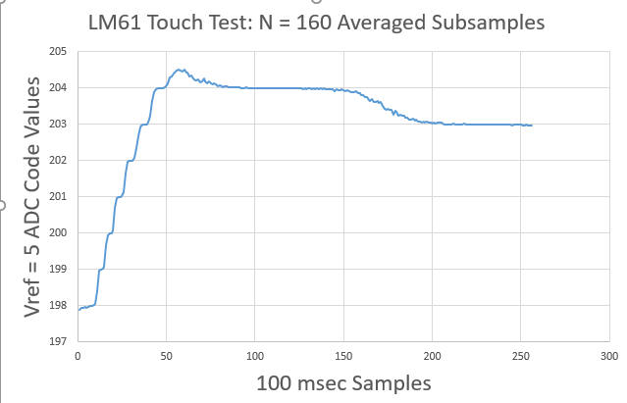

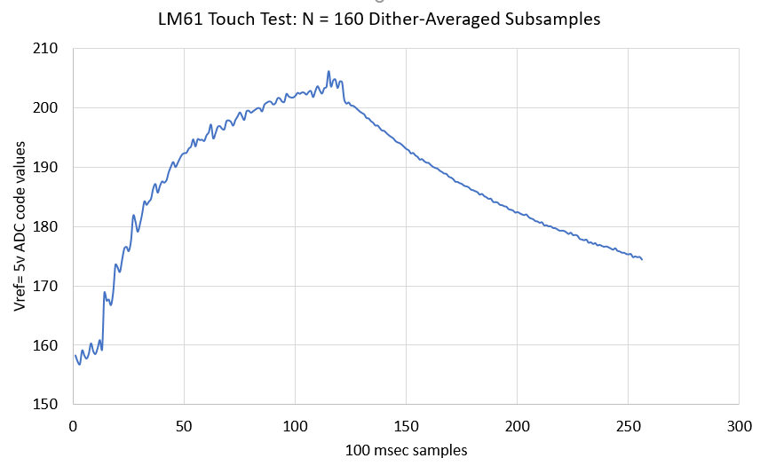

|  |  |  |  |
| --- | --- | --- | --- |
| **Table 2-3 Temperature sensor readings by units with dither and averaging** | | | |
|  | ADC CV | Millivolts | Celsius |
| (5 Vref) |
| mean | 189.76172 | 789.76172 | 18.976172 |
| stdev | 0.8128016 | 0.8128016 | 0.0812802 |
| 1 degC signal | 2 | 20 | 1 |
| SNR(dB) raw | 1.800309 | 1.800309 | 21.800309 |
| Typical error (256 dthr-avg subsamples) | 0.0508001 | 0.0508001 | 0.00508 |
| SNR(dB) (256 dthr-avg subsamples) | 5.1069409 | 5.1069409 | 26.769253 |

1.